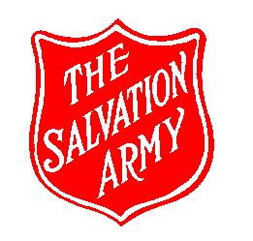
Major
THE COMMUNITY FOOD BANK

TO ACCESS AN EMERGENCY FOOD PARCEL A REFERRAL NEEDS TO COME FROM ONE OF THE FOLLOWING PLACES:

- CITIZENS ADVICE (CAB)
- PRESTON CITY COUNCIL -WELFARE BENEFITS, HOUSING, DEBT ADVICE
- GATEWAY HOUSING
- PLACES FOR PEOPLE (MILLBANK COURT)
- GREAT PLACES HOUSING
- CHILDREN SOCIAL CARE
- CHILDREN AND FAMILY WELLBEING SERVICES
- SOCIAL SERVICES
- POLICE

WE CAN HELP WITH AN EMERGENCY FOOD PARCEL ONCE A MONTH FOR 3 DIFFERENT MONTHS WITH A NEW REFERRAL NEEDED EACH TIME
Additional food banks can be found on www.helpinpreston.com

- BARNARDOS
- MENTAL HEALTH SERVICES
(STRAND RD, CREATIVE SUPPORT, MINDSMATTER)
- BRITISH RED CROSS
- PROBATION/NACRO BASS (BAIL HOSTEL)
- PROGRESS HOUSING (FOUNDATIONS)
- CALICO - SAFENET

